**Practical Workbook**

**Microprocessor & Assembly Language**



|  |  |
| --- | --- |
| STUDENT NAME: | Muhammad Ahsan Khan |
| STUDENT ID: | **FA17-BSCS-0061** |
| SECTION: | **AM** |
| Signature of Faculty: | **______________________________________** |

**Mohammad Ali Jinnah University**

**Department of Computer Science**

**Lab # 07**

**Question 1:**

**Code**

.model small

.stack 100h

.data

arrayB db 60,70,80

arrayW dw 150,250,350

arrayN dw 600,1200,1800

.code

main proc

mov ax,@data

mov ds,ax

mov si,0 ;SI=0000

mov al,arrayB [ si ] ;AL=60

mov si,2 ;SI=0010

mov bl,arrayB [si ] ;AX=80

add bx,ax

mov si,0

mov ax,arrayW[si]

mov si,2

mov bx,arrayW[si]

add ax,bx

mov si,0

mov ax,arrayN[si]

mov si,2

mov bx,arrayN[si]

add ax,bx

endp

end main

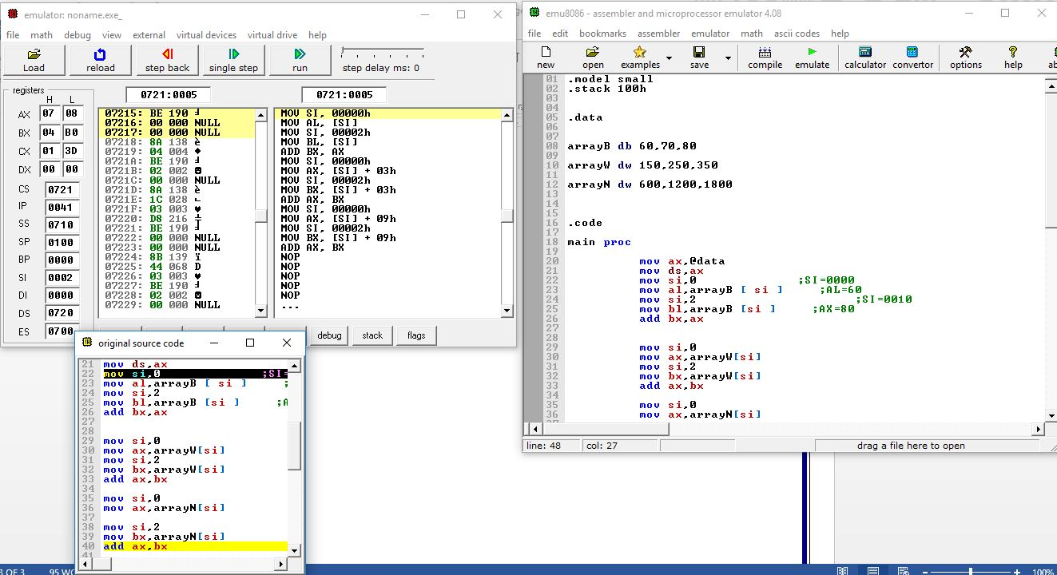

**Question 2**

.code

.model small

.stack 100h

.data

arrayN dw 1000,2000,4000,6000

.code

main proc

mov ax,@data

mov ds,ax

mov ah,2h

mov dx,0Ah

int 21h

mov ah,2h

mov dx,0Dh

int 21h

mov si,0

mov dx,arrayN[si]

int 21h

inc si

mov dx,arrayN[si]

int 21h

inc si

mov dx,arrayN[si]

int 21h

inc si

mov dx,arrayN[si]

int 21h

inc si

mov dx,arrayN[si]

int 21h

endp

end main

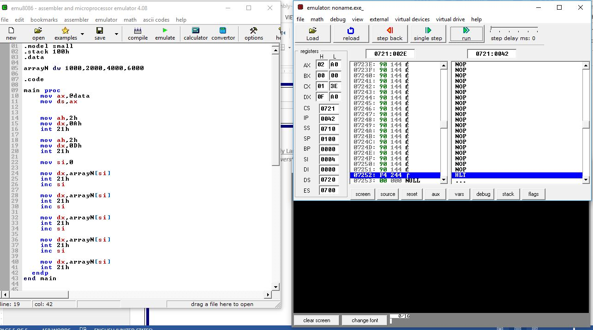

**Question 3:**

.data

arr db 1h,2h,3h

.code

main proc

mov ax,@data

mov ds,ax

mov cx,03h

mov si,02h

L1:

mov ah,02h

mov dl,arr[si]

int 21h

dec si

Loop L1

endp

end main

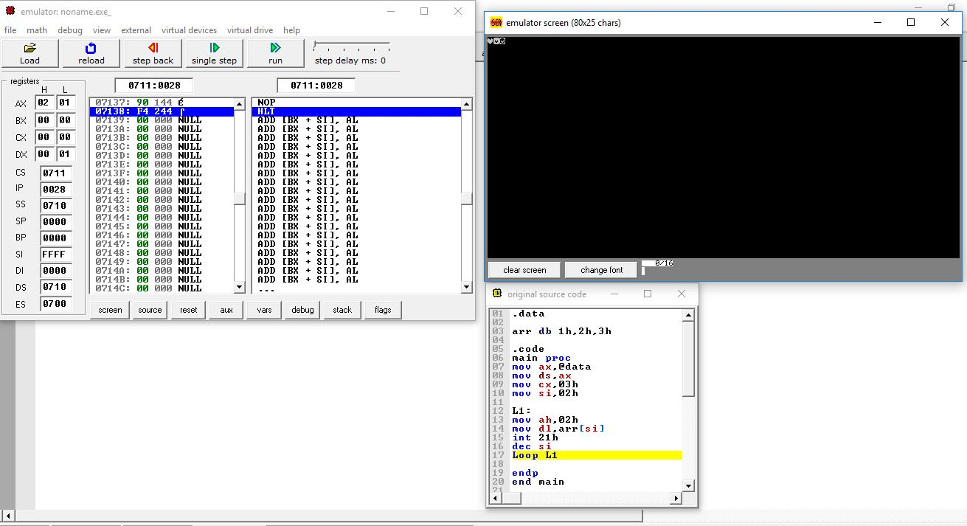

**Question 4;**

.data

ans dw ?

.code

main proc

mov ax,@data

mov ds,ax

mov bx,0

mov dx,1

mov cx,7

L1:

add bx,dx

mov ax,bx

mov bx,dx

mov dx,ax

loop L1

sub dx, 1

mov ans,dx

end main

ret

